Visitor Accommodation Application
Institute of Data, Software Engineering Capstone Project
Presented by Neesh Ellis

Introduction
Purpose
The purpose of my project is to create an application for small to medium size Visitor Accommodation businesses who are currently running either Bed and Breakfast, Airbnb, Home Away, Farm Stays or similar, and would like to have their own direct booking system to integrate or replace their existing revenue channels. This would enable business owners to reduce the % of fees paid to the current booking channels by increasing their own direct sales through the application.
Previously I created a couple of WIX websites, one for myself and one for a client located in a different region of New Zealand. This client recognized the benefits of a direct booking channel. Currently I am aware of a similar private business in Wanaka who have also created their own website, and another party who would like to have their accommodation added to my own application once live. In all cases the applications have integrated their calendars with the Airbnb Calander through an API.
Overall, the results have been positive regarding the creation of a personal direct booking channel. Gross Profit has increased, although net profit is still covering the set-up costs. I need to carry out more work on costings to scrutinize this further.
There are however several factors to consider when embarking on a personal application for Visitor Accommodation versus the Airbnb model that takes care of the roles of many key stakeholders. For example, who is going to maintain the application? Who is going to carry out the marketing, SEO, social media, promotional work and any further development? The likes of Airbnb manage many of these areas currently, so owners will need to either upskill or outsource through a subscription or an hourly rate model to ensure their application stays current. There are many SME throughout the NZ tourism industry who need a broad spectrum of business skills to operate successfully. Often understaffed and lacking the appropriate technical skills, my goal is to provide a locally designed application and service to help these SME flourish.
Industry
Tourism is New Zealand’s biggest services export. Although heavily affected from the pandemic, tourism numbers are steadily recovering. If you consider the overall picture, international visitor spend is second to the Dairy industry as the largest revenue earners for this country. I live in the Cardrona Valley, in between Wanaka and Queenstown, an area heavily reliant on tourism. I, along with many friends provide visitor accommodation for international visitors. Currently Airbnb shows 1.8K listings in the Wanaka District alone. The commission Airbnb takes is approximately 16% per let, a figure not to be sneezed at. Airbnb has 57,000 listings in New Zealand…Along with Airbnb there are other platforms operating in a similar fashion, so it’s a big revenue stream. To offer a service where the rate of commission is reduced for both the customer and the provider is a win, win. My objective is to provide an alternative booking solution, smaller scale but has the ability for boutique customization which currently the big providers such as Little Hotelier are unable to offer with their generic product. Thinking longer term the idea of a customized booking system could be considered for other parts of the tourism industry such as activities. I have included an activities web page in the application, to give an idea of how this too could be developed further, eventually adding a mapping overlay to link the accommodation and adventures through geography.

Stakeholders
Internal
- The owners/property manager of the accommodation
- The person responsible bookings, payments, finance
- Person building, maintaining the website
- Legal obligations such as health & safety, tax rules and accommodation laws
- Marketing person who overseas SEO, promotional material, social media

The internal stakeholders with access to the software would include the owners of the accommodation. Thereafter it depends if the owner wanted the site managed or not. The purpose of the software is to decrease the commissions being currently paid to booking agents, and to provide a more personal, product for the customer.

3 business models for the accommodation owners
- Property owners who want a site created using the application template. The site is then handed over to the owner with no further obligations form either party.
- Property owners that want a site created but then managed by a third party.
- A property owner who would like to list on this application.
External
- The guests
- Property owners who would are listing on this application
- Suppliers such as cleaners, laundry providers, gardeners
- Online payment provider such as Windcave and Westpac
- Queenstown Lakes District Council for VA consents and Lake Wanaka Tourism for advertising
- Technology partners who host the site, third party booking integrations such as Airbnb
- Insurance companies providing dwelling, contents, public liability cover
- Media Marketing Channels such as Trip Advisor, Google reviews, Facebook, Instagram, TikTok

The main external stakeholder, the guest, has an expectation of being able to book accommodation directly, avoiding the extra booking fees that are currently part of third-party agents. The adventure page of the application will provide a one stop shop for tourism experiences. The goal to provide a link to maps showing the location of the various tourism attractions including restaurants, walking and biking tracks.

The Queenstown Lakes District Council has created a Tourism Management Plan where regenerative tourism is the goal. A place where the land, water and community thrive as one.

Product Description
Frontend Design – Figma
https://www.figma.com/design/XL2xSz4jjLswODPDd37VLA/Capstone-Project?node-id=2010-687&t=BfUv3NOceQ2cgof9-0
Web application with 10 pages, a Navigation Bar, Login/Sign Up page and Footer
Home Page - the user lands on the page which describes the Visitor Accommodation offering, scrolling down to a guest Reviews panel, Book to Stay button and a panel showcasing some of the activities in the region.
Login Page/ Sign Up
Accommodation – dropdown menu showcasing the three pages of different accommodation – button to link through to Bookings page on all three pages
Bookings – Includes a form, Calendar to check availability and a BOOK/BUY now button. Here a payment Gateway would be linked to the application, and any API’s that are required to be integrated with the Calendar.
Activities in Wanaka – show cases the best Tourist experiences, with a form to complete for inquiries to book
Reviews – includes a dropdown menu of two pages. Page 1 showcasing left reviews, Page 2 a login page for previous customers to leave a review. Page 1 to link live to Page 2, so after a review is left, it is immediately posted to the application.
Contact Us – complete a form and send all inquiries through. No need to login or register to send a review
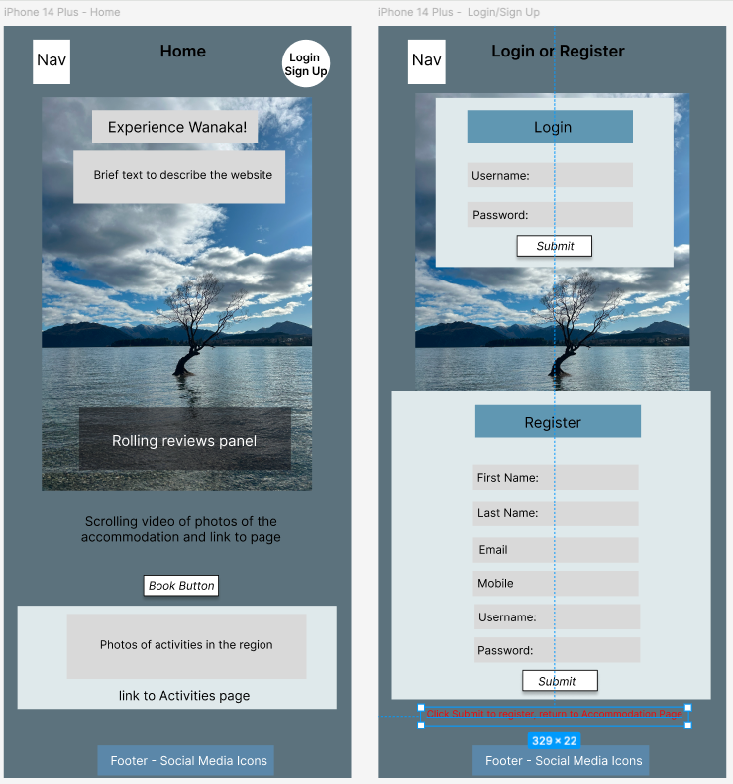
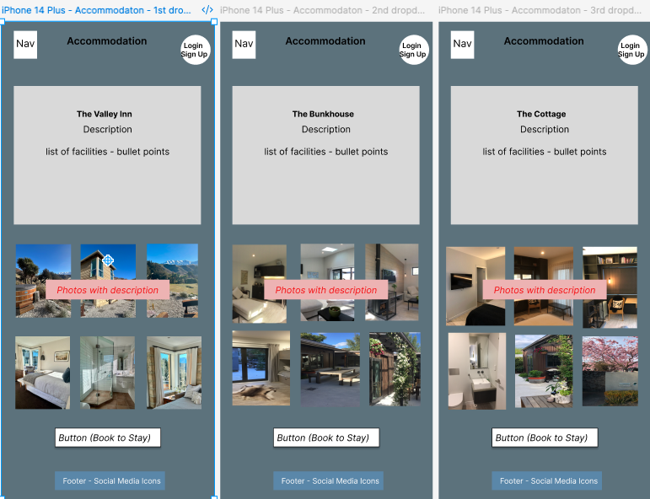
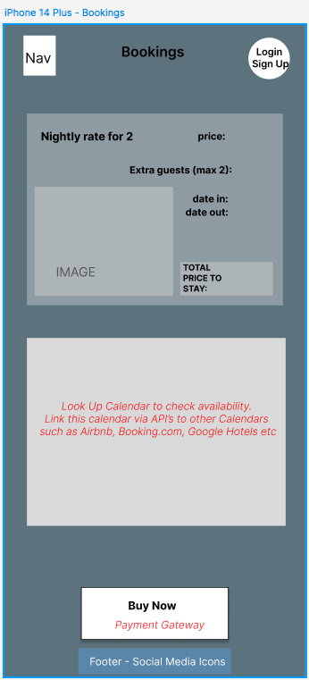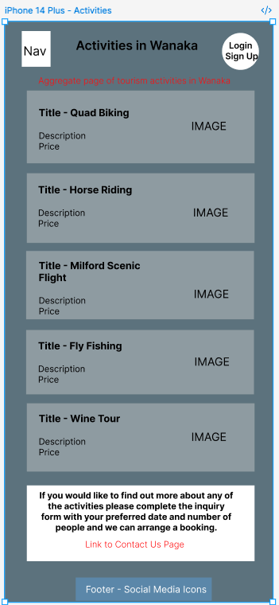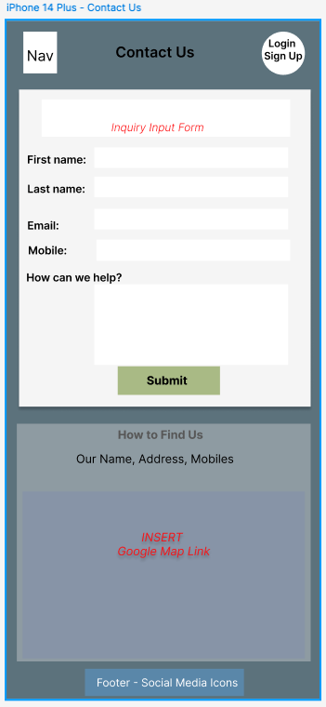

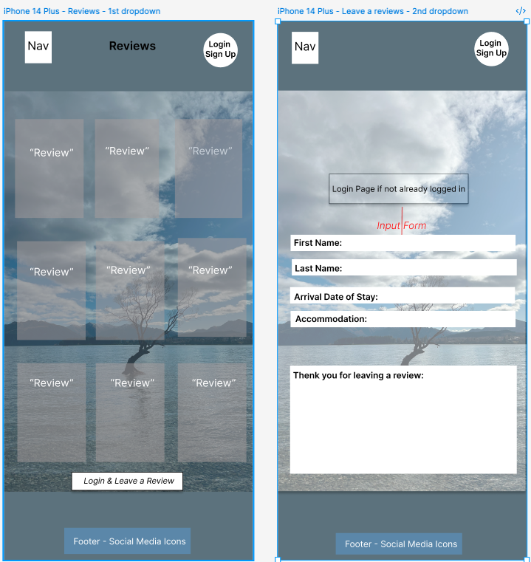

User Flow – Figma
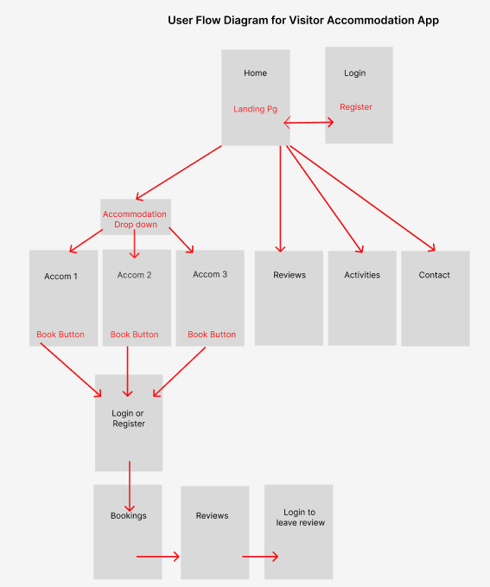

Backend Design - drawio
I used drawio to design my Logical and Physical Database structures as illustrated below.

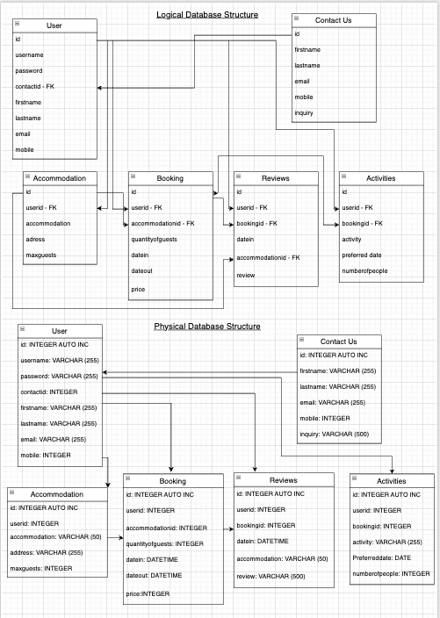

User Stories
As a national tourist traveling within New Zealand, I want to quickly find, compare, and book accommodation in Wanaka. I want to plan a short getaway or holiday with minimal effort, confident that the options suit my budget and travel style. I want something special and unique but preferably a great location to skiing and other facilities.
As an international tourist visiting New Zealand, I want to explore accommodation options in Wanaka with detailed descriptions, photos, and local activity recommendations. I’m looking for a place to stay and activities to do that are unique and have a great reputation, a place to create memories. I want a place that gives me both comfort and authentic local experiences, making my trip memorable and hassle-free. I want a personal touch when it comes to interaction with my accommodation provider.
As a business traveler attending meetings or conferences in Wanaka, I want to find accommodation with reliable internet, workspaces, and flexible check-in/out options so I can balance productivity with comfort during my stay. I would prefer to book direct as appose to using a third party as generally you get better rates and can create a relationship with the owners, travelling for business can be lonely continuously being on the road.

Non-functional Requirements
Security for the user’s login details will be important as users are uploading personal information. The application will need to timeout if the user has not been active after a certain period. More importantly though is the payment gateway. Tavel Bookings are renowned for being scammed. Whilst making a personal payment transaction for overseas holiday accommodation recently through WISES, I was asked on numerous occasions by the system was the supplier reputable as 75% of similar payments of this nature were scams. This needs to be from a reputable secure supplier such as Windcave or PayPal. Shopping around for competitive credit card percentage rates or running with a clients preferred supplier will be also a factor to consider.
Software updates – the application will need to be maintained and checked for regular software and library updates to maintain its reliability.
The number of transactions won’t be an issue unless the application was expanded to list many different accommodation places. Each accommodation offering will need its own booking calendar, although I have just shown one in this example. The calendars will need to be integrated with other supplier’s calendars such as Airbnb to ensure the total bookings for that property are visible in the application, so to avoid double bookings.

Product Planning
I used a Trello Board to manage the project. I created checklists and due dates for each stage to keep the momentum going and a record for future reference.
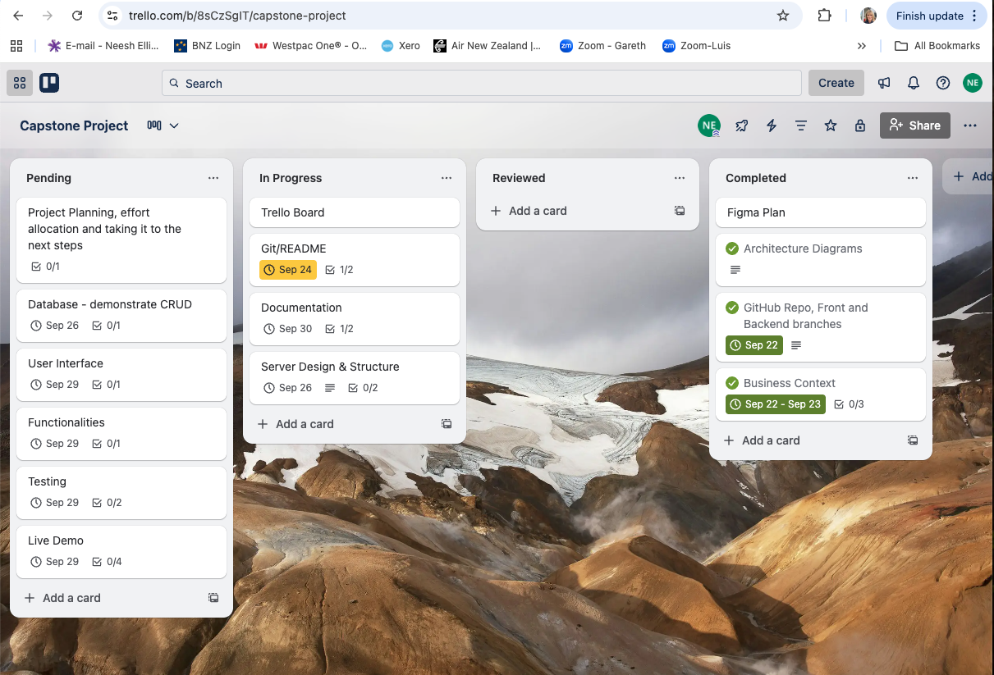

Implementation
To build, test and implement the frontend application during the production phase I used Visual Code and utilized the ‘dev’ script in package.json. This script starts a development server that automatically loads the application every time any changes are made which makes things quicker. The command to do this is npm run dev.
To activate the data from the json file, I had to start the sql server by typing json-server data.json in the terminal.
Once the frontend application was complete then I merged with the backend.

End-to-end solution
The aim is to complete the whole application by connecting a payment gateway to the BUY button. I would like the Contacts Table to link through a foreign key to the Users Table, so the user can keep a track of the number of inquiries that end up in a Booking.
The Activities Page I would like to develop as an aggregator for local tourism businesses. Any bookings that are directed to an operator via the site would initiate a commission payout (but less than the current average of 20%). The Contact Us model would be an effective way to gauge if sales are achieved through this page. Some bookings could potentially originate here and lead through to a sale.
Social media channels could link through to the other local businesses on the adventures page, so an umbrella marketing campaign could produce a louder noise than just an individual business. Currently we have the Lake Wanaka Tourism website which is a large aggregator for the area. However, providing a boutique offering, with tailored accommodation choices and products from a trusted source is key. Tourists are looking for unique experiences that offer that personal, local touch. If this is delivered to a high standard, then repeat business will result in growth going from strength to strength. This, coupled with a reduction in commissions paid to booking channels should increase overall net profits.

References
GitHub link - https://github.com/neeshellis/Capstone
Figma link - https://www.figma.com/design/XL2xSz4jjLswODPDd37VLA/Capstone-Project?node-id=2003-40&p=f&t=QRQZX9qe99rThk2E-0
Architecture link - https://app.diagrams.net/index.html#G1eXFKN1syOYKPZVys__Xshh5cXbktnydo#%7B%22pageId%22%3A%22pmqTT4KoNxFkYP61keCS%22%7D
Tello - https://trello.com/b/8sCzSgIT/capstone-project
The project was built using Node.js (a javascript runtime environment) in Visual Code.
Node Package Manager, a library of javascript pre-saved scripts was used to create the structures for the backend and frontend.
The frameworks used were Express and Next.js
The frontend application was built using React Library and Vite which is a tool that builds and bundles an application to create a faster server start up.
MUI was the library used to create the User Interface.
To populate the JSON data file, I used ChatGPT.
I used Google and Claude AI when I was brainstorming code issues or searching for error messages

